SQL ASSIGNMENT 1

1. SALSPEOPLE;
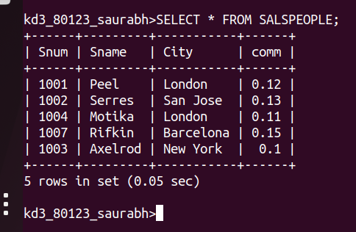

2. CUSTOMERS

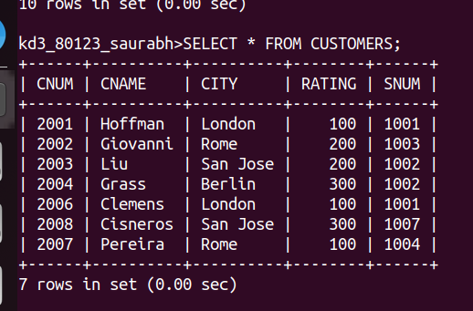
3. Orders;

